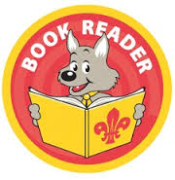 |  | Name: ...........................  Six: ...............................

On this page write down yourself books you have read over the holidays. Choose 3 of these books to tell Akela more about them on the next page. Return this form back to Akela who will then ask you about some questions about how to care for books and how you find books in libraries. You will also need to show Akela how you can use a dictionary and atlas. Remember ‘Cubs do their best’

Book | Title | Author | Parent Initials
1

2

3

4

5

6

7

8

9

10

11

12

Book | Title | Write down what was the story about. How did the story end? What you liked about this book ?
1

2

3

